Sri Lanka Institute of Information

Technology



Lab Submission

<Lab sheet No 08>

**<IT24101350>**

**<Hansanganee H.R.S.S>**

**Probability and Statistic | IT2120**

B.Sc. (Hons) in Information Technology

Exercise

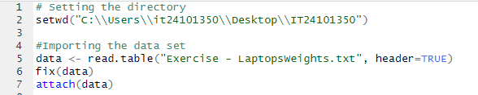

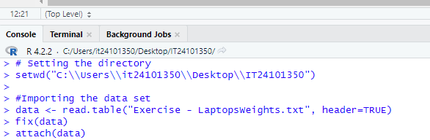

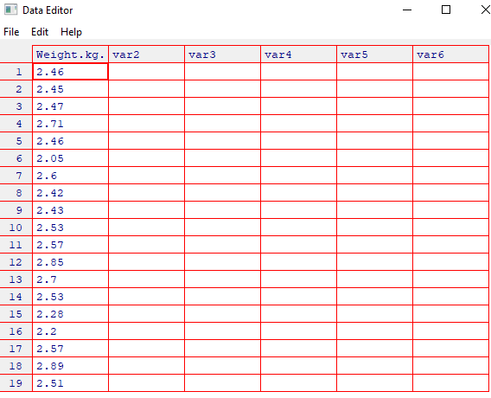

1. 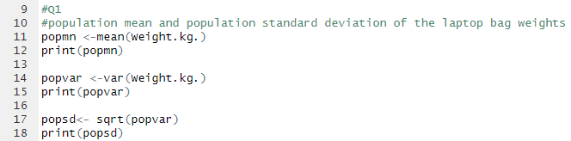 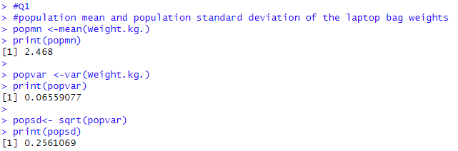

1. 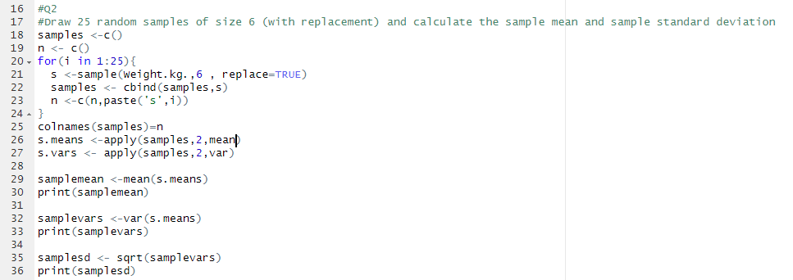

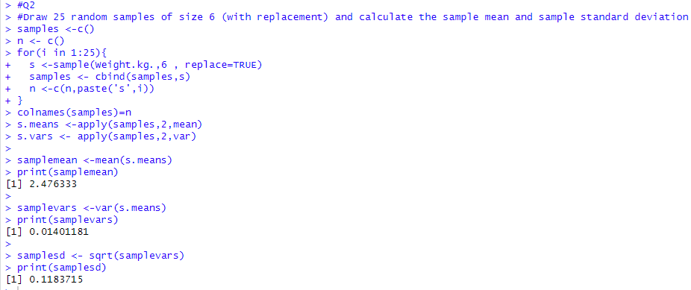3) 